|  |  |
| --- | --- |
| http://sphotos.ak.fbcdn.net/photos-ak-snc1/v2219/119/28/51288393663/n51288393663_1327303_6197.jpg | old_logo_color |

ASSIGNMENT Week 1

CNN

By

Ahmed Usama Khalifa

Submitted to

Dr. Omar Nasr

Electronics and Electrical Communications Engineering Department

FACULTY OF ENGINEERING, CAIRO UNIVERSITY

GIZA, EGYPT

### Foundations of Convolutional Neural Networks

Padding

**Padding** is a term relevant to convolutional neural networks as it refers to the amount of pixels added to an image when it is being processed by the kernel of a **CNN**. For example, if the **padding** in a **CNN** is set to zero, then every pixel value that is added will be of value zero

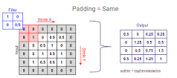

Stride

**Stride** is the number of pixels shifts over the input matrix. When the **stride** is 1 then we move the filters to 1 pixel at a time. When the **stride** is 2 then we move the filters to 2 pixels at a time and so on. The below figure shows convolution would work with a **stride** of 2.

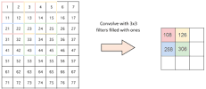

Filter

In convolutional (**filtering** and encoding by transformation) neural networks (**CNN**) every network layer acts as a detection **filter** for the presence of specific features or patterns present in the original data. The first layers in a **CNN** detect (large) features that can be recognized and interpreted relatively easy.

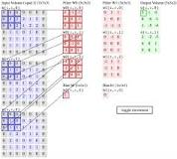

Pooling operation

A **pooling layer** is another building block of a **CNN**. Its function is to progressively reduce the spatial size of the representation to reduce the amount of parameters and computation in the network. **Pooling layer** operates on each feature map independently. The most common approach used in **pooling** is max **pooling**.

